INFORMATION FOR SCOTTISH PARTICIPANTS
38th Scottish International Patrol Jamborette
Blair Atholl 2022

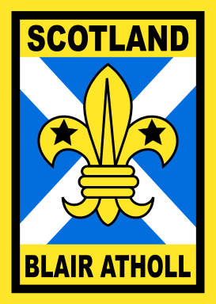
www.jamborette.org.uk
38th SCOTTISH INTERNATIONAL
PATROL JAMBORETTE
BLAIR ATHOLL
Monday 18th to Friday 29th July 2022

Hi!!

I am delighted that you have been selected to represent your Region at the 38th Blair Atholl Jamborette and I look forward to welcoming you to the camp.

The invitation that has been sent out to overseas Scouts from the Scouts of Scotland was:
“to come and camp along with us at Blair Atholl”

I hope this leaflet will provide useful information to assist in your preparation for the camp.

Your Regional Co-ordinator for Blair Atholl will be making you aware of your region’s arrangements. I am sure your Region has been organising meetings and/or weekend camps so that you can get to know the others in your patrol, select and collect your equipment, and learn about the Blair Atholl Jamborette from a member of staff or someone who has been at a Jamborette before. The value of this preparation cannot be overstressed.

Blair Atholl Jamborettes have always been hugely successful and tremendous fun. I am sure you too will have a great time and help to ensure our visitors from many parts of the world will have the most pleasant of memories of Scotland and Scottish Scouting.

Please come up and introduce yourself to me at the camp and let me know how much you are enjoying the unique Blair Atholl experience. In the meantime, follow @BAJamborette on Instagram, Twitter & Facebook for information before and during the camp and tag us in your posts.

Yours sincerely
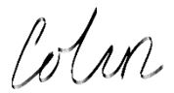
Colin Peters
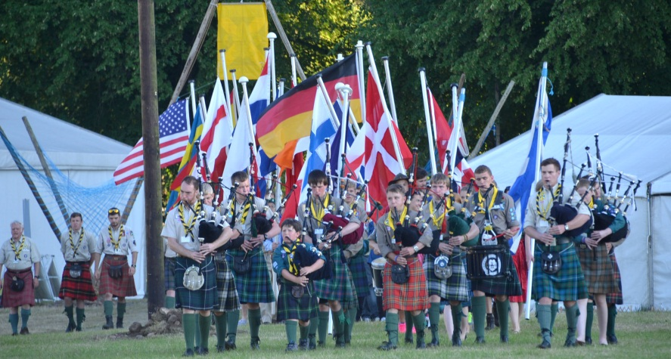
Camp Chief
CAMP ORGANISATION
Scottish patrols will comprise six Scouts, with one appointed by the Region as Patrol Leader and one as Assistant Patrol Leader and should plan to arrive during Monday 18th July to set up camp.

At the Jamborette there will be six sub-camps, each named after a Scottish clan - MacDonald, Maclean, Morrison, Murray, Robertson and Stewart, and there will be a sub-camp Leader with several assistants, including overseas Leaders. In each sub-camp there will be up to fourteen 'Double Patrols', each comprising one Scottish patrol and one Overseas patrol, which are twinned together for the camp.

This means that you camp and work together, and as a joint patrol, probably do a lot of activities together during the camp.

The camp will disperse during the day on Friday 29th July, and the arrangements to get everyone home will be announced in good time during the camp.

CAMP SERVICES
A large staff of Scottish and overseas Scouters and Scout Network members will provide the numerous services and activities at the Jamborette.

There will be a Café, facility for mobile phone charging and Shop within the camp. All will accept contactless payment therefore we recommend bringing a prepaid card or bank card and minimal cash as there will not be a bank facility at the camp. There is a medical facility with doctors and staff. We recommend breaking in new footwear and dealing with ingrown toenails well before camp. Changing regular prescriptions immediately before camp should be avoided if possible.

CAMP ACTIVITIES
These are numerous and very varied, hopefully to suit every interest and taste. They will include Scouting activities, exploration, hikes, wide games, visits to places of interest, adventurous activities on land and water, pioneering, community projects, sports, films, campfires etc. There for performing, reflection as well as our campfires and Scouts Own service.

If you or your patrol can put on something at a campfire, please come prepared. The playing of musical instruments at campfires and performances is always encouraged, especially bagpipes!

VISITORS' DAY
The camp will be open to visitors, parents and friends on Saturday 23rd July and there will be a range of special events including an International Country Fair, displays and other activities, ending with a big International Campfire in the evening. Tea, coffee, and refreshments will be on sale to the public during the day.

INTERNATIONAL PARTIES
It is the custom at Blair Atholl to have patrol parties when your patrol invites Scouts from different countries to come along to your site. It would be helpful to come prepared with:
- pre-printed invitation cards of some kind, perhaps about 20/25.
- items of Scottish fare such as cakes, shortbread, oatcakes etc
- items to decorate the table e.g. tartan serviettes etc

Anything you can do in this way will greatly add to the fun of the camp - remember to bring a few badges or souvenirs or gifts for swapping.

PERSONAL EQUIPMENT
Each Scottish Scout should bring the normal personal kit, packed in a rucksack, for a ten-day camp.

Take care to clearly label your possessions

You will require at least:

Scout uniform including kilt |  | T-Shirts / shorts
Nightwear |  | Waterproof clothing
Sleeping bag (for temperatures to 0^{oC}) |  | Windproof Jacket  Water bottle
Sleeping Mat |  | Training shoes
Warm sweater |  | Boots or strong shoes
Trousers |  | Underwear
Plenty of spare clothing |  | Extra socks
Swimming kit |  | Plastic mug, plate, bowl
Small and large towels |  | Cutlery
Toiletries (no aerosols) |  | Note-pad and pen
Mosquito repellent  Warm hat & sun hat |  | Torch and spare batteries
Sewing kit (yellow or clear thread) |  | Camera (optional)
Suntan lotion |  | Day sac / rucksack
Towels |  | Nail brush
Battery Pack (Solar?) for device charging

- Denim jeans are not suitable for hill or water activities
- Aerosol cans and speakers for MP3 players / phones should not be brought to camp.

Please ensure that all your own personal equipment is adequately insured and labelled with your name where appropriate.

Please ensure you are familiar with all your personal equipment and your patrol equipment. You are responsible, along with the rest of your patrol, for the care of all you bring to the camp, and for ensuring that it all goes back home with you.
UNIFORM
Every Scout should travel in full and correct Scout uniform. Scottish Scout uniforms are:
- kilt with a plain leather sporran, lovat green kilt socks (not ankle socks) and black shoes.
or
- tartan skirt or kilt (without sporran, green socks, or garter tabs.) and black shoes.

All young people should be comfortable in the uniform they choose to wear.

Spare uniform socks are strongly advised. It is stressed that the kilt or tartan skirt is essential at this International Scout event.

A special camp neckerchief and badge will be issued at the Jamborette - the badge cannot be replaced under any circumstances, so please look after it.

A knife is not part of Scout uniform. If you want to bring a knife for use in camp it should be a clasp knife, not a sheath knife.

COOKING
All cooking is done on open fires (wood supplied). Another means of cooking may be brought but this will only be for use in an emergency. These stoves must meet current regulations, serviced, hoses and regulators in date. Petrol stoves are not allowed.

TIMBER
There will be ample supplies of wood for burning and for campsite furnishings, gadgets and decorations. Patrols should give thought before the camp to the type of gateway to be constructed. Each patrol will have sufficient timber to construct a dining table/shelter incorporating an altar fire (see design details provided to Regional Co-ordinator).

RUBBISH DISPOSAL
All rubbish that cannot be burnt or recycled is collected under Sub-Camp arrangements. Glass, aluminium, cardboard and plastic is all recycled.

WET PIT
A bucket, covered with a suitable screen to catch solids for burning should be brought. Wet pits will not be dug at this year’s camp.

HEALTH & HYGIENE
It is vital that everyone in the camp practises good personal hygiene. Hand sanitisers should be used throughout the camp. Toilet provision at the camp is portaloos and male urinals. Please ensure that you use the hand washing facilities provided at the exit from all toilets.

Warm showers are available at certain times each day.

All Patrols are required to provide a suitable, dedicated hand washing basin and everyone should ensure hands are washed before preparing or eating food. Sub-camp staff and the camp medical team will monitor this and provide advice as required.

Drug or alcohol use will not be tolerated.

FIRE SAFETY
Each patrol is responsible for fire safety within its own campsite. All reasonable precautions should be observed.

POSTAL ADDRESS
Letters should be addressed:
Your name
Name of Region / Contingent
Scout International Camp
BLAIR ATHOLL
Perthshire PH18 5TL

EMERGENCY TELEPHONE NUMBER
In case of emergency, messages can be left with the Camp Office. The new number for this has still to be issued and will be shared with each Region as soon as we know it. A message will then be given to you and you can ring the caller back.

COST
The Camp Fee is £350.00 which covers all food, camp services, activities, camp badge and neckerchief. Your Region will have arrangements to collect the fee and send it to Scottish Headquarters before the camp.

CAMPING STANDARDS
Our visitors are coming from overseas to a country totally strange to them and will be very interested in our Scouting and camping methods.

Scottish Scouts should aim to set the highest possible standards of camp lay-out, hygiene, storage of food, cooking and serving meals to ensure that our Overseas Scouts have a truly unforgettable experience.

